BRYAN ADI PRAKOSO  
20050974058  
PTI 2020 B

1. PHP - json_encode()
   1. 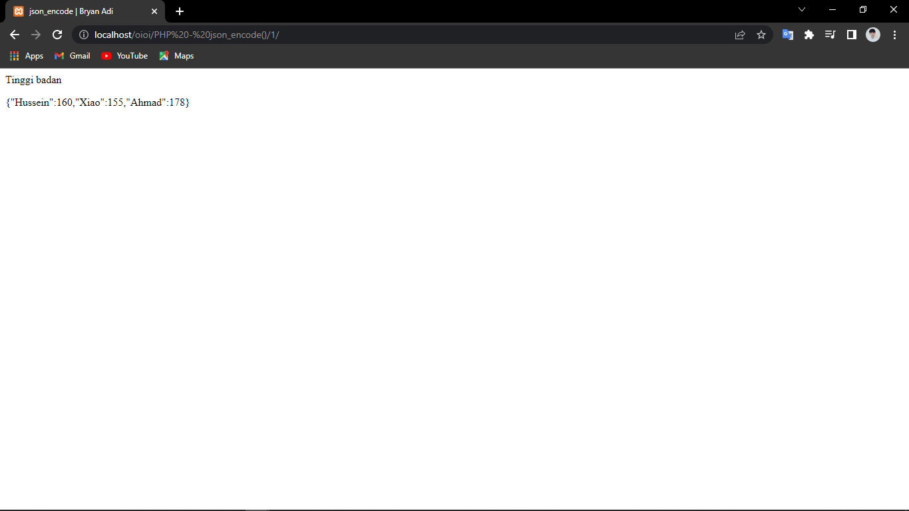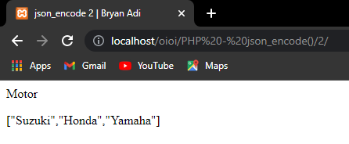
2. PHP - json_decode()
   1. 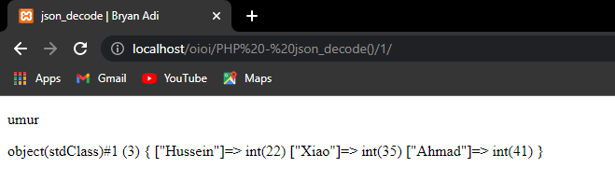
   2. 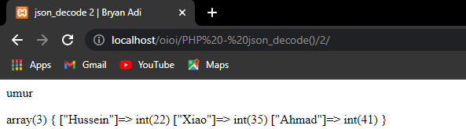
3. PHP - Accessing the Decoded Values
   1. 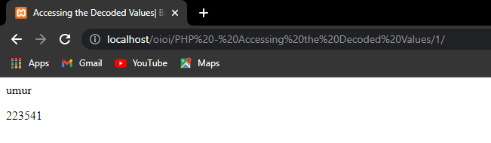
   2. 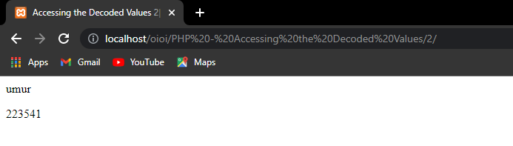
4. PHP - Looping Through the Values
   1. 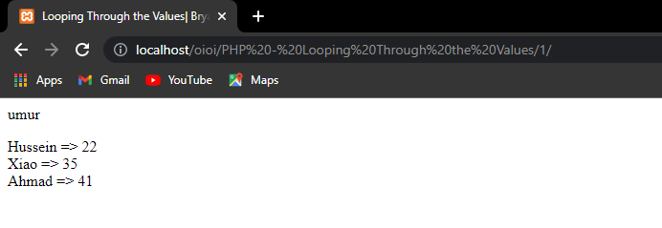
   2. 